Assignment 2

**Question 1**

What is the value of clothes[0] and why?

const clothes = ['jacket', 't-shirt'];

clothes.length = 0;

console.log(clothes[0]);

**Answer:--**

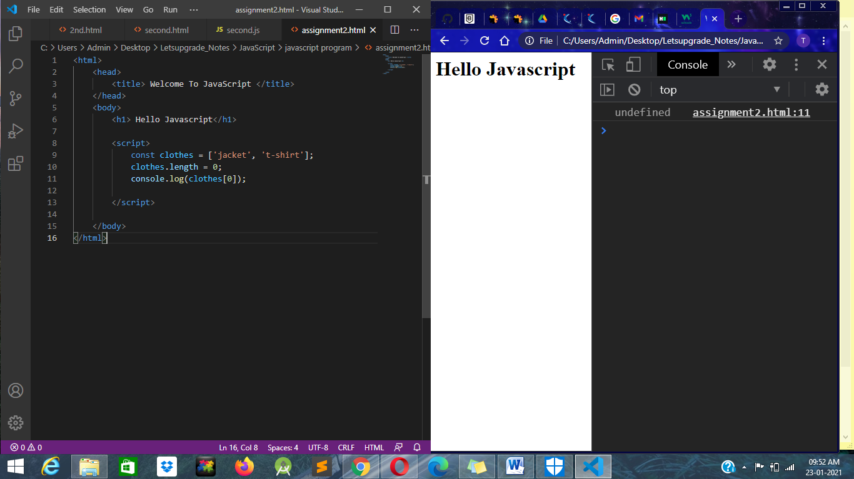

**Question 2**

Write a JavaScript program to find the sum of all elements of a given array?

**Answer:-**

**Code write in Script block :--**

 var arr=[23,34,45,56,67];

            var sum = arr.reduce(function(a,b){

                return a+b;

            },0);

            console.log(sum);

